Off the Coast, On Plates?: Comparing fishery data with seafood offerings and sustainability messaging at restaurants in Portland, ME and Cape Cod, MA

Anna Yankee¹, Katherine Maltby², Katherine Mills², Adam Baukus², Kyle Foley², Sophie Scott²

¹ Hamilton College, Clinton, NY, United States
² Gulf of Maine Research Institute, Portland, ME, United States

[Insert preferred bibliography citation here]

Abstract

Consuming local seafood species, especially those that are new to the local ecosystem and not yet in high demand, is a powerful strategy for increasing sustainability, bolstering climate change mitigation, and supporting local economic resilience. However, while New England is known for its seafood, there is little academic research on the sourcing and variability of species offered at regional restaurants. More information about restaurants’ current interactions with local seafood supply chains could help inform efforts to increase local and diverse seafood sourcing, particularly in the context of ocean warming, which is bringing species that are less familiar to consumers into local fishery harvests.

This paper evaluates how seafood offerings at restaurants in Portland and Cape Cod compare with current fishery landings and develops insights into the potential for restaurants to source a greater variety of local seafood, especially in the context of climate-driven species distribution shifts. This analysis was carried out by first comparing regional commercial marine fisheries landings data with restaurant menus in each area. Values, priorities, challenges, and opportunities in the restaurant industry were then assessed by analyzing restaurant websites and conducting five key informant interviews. Key findings are as follows:
- Portland and Cape Cod restaurants offer far more diverse seafood options than are generally represented in the average American diet, and the types of seafood most commonly offered can be landed locally.
- There is more general sourcing information on restaurants’ websites than there is specific information on menus.
- Forward-thinking restaurateurs are excited about introducing the public to less common species, but successfully putting these species on the menu may require coordinated operational shifts in multiple areas of the business.
- Restaurateurs can draw on several opportunity areas when deciding how to incorporate more diverse, local seafood. The success of particular strategies will hinge on factors both external and internal to the restaurant, and different strategies apply to different seafood types.

Restaurants can play a key role in shaping the future of seafood consumption because of their influence on consumers and leverage in supply chains. This study provides insights into how restaurants currently build demand for local seafood and identifies opportunities for restaurants to increase their support of local fisheries and coastal communities as climate change shifts species available in the Gulf of Maine.

Introduction

Harvesting, trading, and consuming seafood has long been integral to the New England way of life. The relationship between New Englanders, their plates, and the sea is so significant that entire volumes have been dedicated to the cultural and economic importance of local species (Kurlansky 1998; Seaver 2017). While the importance of seafood is a constant throughout New England history, the history of specific fisheries is more variable. Technological advances, like more efficient fishing gear and refrigeration capabilities, paired with fluctuating consumer demand and fishery management has led to dramatic shifts in biomass of commercially fished species and in both the relative and absolute abundance of landings of different species (NEFSC 2022). Rapidly increasing ocean temperatures are now driving reorganization of marine ecosystems, as some stocks benefit and others suffer from changing conditions (Le Bris et al. 2018, Pinsky et al. 2020). These changes are altering the species available to fisheries, resulting in harvest of new species for which markets and consumer demand may not yet exist. The effects of both changing fishing pressures and climate change have major implications for over 200,000 New Englanders who rely on the seafood industry for their livelihoods (NMFS 2021).
The sustainable seafood movement in the United States began in the 1990s as a non-governmental coalition to promote more environmentally and socially responsible seafood supply chains (Gutiérrez & Morgan 2015). Eco-certification programs, most notably that of the Marine Stewardship Council (MSC), are often at the center of global sustainable seafood efforts (Jacquet & Pauly 2008b). While global seafood systems continue to improve, local seafood is considered particularly environmentally and economically beneficial (Alden 2011). However, seafood is often excluded from the mainstream local food movement, which has long been a powerful force shaping narratives around terrestrial food production (Olson et al. 2014). While transnational certification schemes can serve as a valuable tool for consumers and retailers looking to source their seafood more responsibly, the sustainable seafood movement is incomplete without community-oriented efforts across localized supply chains (Gutiérrez & Morgan 2015; Jacquet & Pauly 2008b; Olson et al. 2014).
Consuming local seafood is one way consumers can lessen their environmental footprint. Eating domestic seafood is an especially powerful strategy for climate change mitigation because most aquatic species have lower carbon footprints associated with production than land animal proteins and lower carbon footprints associated with transportation if harvests are consumed locally (Gephart et al. 2016, Gephart et al. 2021, Hallström et al. 2019). However, global supply chains currently favor importation. The overall balance of trade in edible seafood products in the U.S. was a deficit of $17.0 billion in 2020, meaning more seafood was imported than exported (NMFS 2022). Imported seafood often has a higher environmental impact because of transportation emissions (Seafood Carbon Emissions Tool 2023) and poor transparency practices (Jacquet & Pauly 2008a).
Consumer consumption of a diverse variety of seafood also provides an avenue for supporting local fishing communities. Currently, three types of seafood—shrimp, salmon, and tuna—make up over half of the seafood eaten in the United States (Chase 2023). Consumption patterns do not reflect the diversity of seafood landed in the U.S (Love et al. 2022). Some species are exported or used as bait, and many are fished below their maximum sustainable yield because of low demand (Oremus et al. 2023). Importantly, when demand increases for underutilized species, pressure on overfished stocks can lessen and fishermen benefit financially (Davis 2020). Diversified fishing portfolios also increase resilience among fishing communities by decreasing reliance on any one stock (Stoll et al. 2021, Witkin et al. 2015).
Building local demand for underutilized species is especially important in the context of warming oceans, as species move into waters where consumers may be unfamiliar with them. However, because retailers and restaurateurs often sell products they think consumers will want, even adventurous eaters may face difficulties sourcing less popular species. Recent research has confirmed that New England consumers have limited access to underutilized local species in both markets and restaurants (Davis 2020, Masury & Schumann 2019). Although states like Maine and Massachusetts are fueled by seafood-related tourism, it is often unclear whether the seafood at restaurants is actually local, and menus may be limited to a narrow array of species that do not necessarily reflect the diversity of species harvested by nearby fisheries. As a result, consumers are unfamiliar with these species, thus contributing to the cycle of low demand and limited supply.
Just as the working waterfront helps attract customers to restaurants, restaurants have an important role in supporting local fishermen in the context of climate vulnerability. Restaurants can be leaders in identifying underutilized species that are emerging in an area and that are expected to be resilient to climate change (Davis et al. 2023). Although a singular restaurant might only purchase a small amount of a local underutilized fish, restaurants can have a larger impact because of their influence in the supply chain and on consumers. Restaurants have the ability to request and procure less common species from suppliers, meaning that they can help modify existing seafood supply chains and spur new supply chains. A restaurant might inspire other restaurants to also branch out to other species, and the consumers that eat at these restaurants might be inspired to try cooking these fish at their own homes. In this way, diversified, local seafood can scale from a single restaurant to a community level solution. Local restaurants and local fisheries are therefore well-positioned to help each other succeed: the seafood sector contributed over $3.2 billion dollars in total economic output to the Maine economy in 2019, $692 million of which was in retail (SEAMaine 2023). At the same time, an estimated 65% of seafood spending occurs outside the home (Love et al. 2020). The restaurant industry has the potential to increase environmental, economic, and social resilience in their communities by offering and promoting local species, especially species that are new to the local ecosystem and not yet in high demand.

Research Objectives

The objective of this research is to evaluate how seafood offerings at New England restaurants compare to corresponding regional fishery landings, and what factors might enable the availability of diverse, local seafood to increase. Portland, Maine, was chosen as a case study because of the long history and centrality of its working waterfront, combined with a vibrant culinary culture. Cape Cod was selected as a point of comparison because Southern Massachusetts is already experiencing species shifts that Maine is expected to experience in the near future. It is important to note that "local" can be defined in a variety of ways, but for purposes of this study, we examine seafood offerings in a geographically-specific, port-focused manner to align with fishery landings data. The main research questions examined in this study are as follows:

- How diverse are seafood offerings at restaurants in Portland, Maine and Cape Cod, Massachusetts, and how do they compare with current fishery landings?
- What factors (e.g., consumer expectations, restaurant values, changing availability of product) may influence the potential for restaurants to source a greater variety of local seafood?

The end goal of this research is to identify opportunities for the restaurant industry in New England, and Maine in particular, to employ local seafood initiatives with the aim of supporting regional fisheries in the context of fishing and climate vulnerability.

Methods

Current Landed Species Identification

To examine seafood currently landed in Portland and Cape Cod, species were identified from a database of non-confidential fisheries landings data from the Greater Atlantic Regional Fisheries Office. For the purpose of simplicity, we identified species to be currently landed in the Portland area only if they were landed in Portland between 2016 and 2021 and species to be currently landed in Cape Cod based on landings in Chatham, Nantucket, or Provincetown during that time. The total volume of each species landed between 2016 and 2021 was calculated in pounds for each area (Portland and Cape Cod). Some landings are reported without a species name to preserve confidentiality if there are fewer than three harvesters or dealers for a given species. For the purposes of this study, only species that were named in the data set were recorded as landed in that port.

Menu Analysis

Restaurant Selection

To analyze seafood on offer at regional restaurants, a database was created of menus in Portland and Cape Cod. Restaurants were selected from the regional lists Portland Food Map, an online directory and blog (portlandfoodmap.com) and Cape Cod Life, a website and magazine (capecodlife.com). These lists were chosen because they represent a comprehensive selection of different restaurants in each area, split into categories to enable easier analysis. Restaurants that had a dinner menu online with at least one seafood dish were considered. To limit the sample size and reduce bias in levels of seafood offerings owing to diverse restaurant cuisine types, restaurants were added to the database only from select categories on each list. Categories unlikely to serve seafood (e.g. “Coffee House”) and categories with an international focus (e.g. “Japanese”) were not assessed. It is important to note that local seafood availability is often seasonal, so distribution of seafood types offered at restaurants likely differs at different times of the year. Only menus from the month of June were considered in this study to standardize for seasonal differences and align with the timing of data collection.

Portland
Portland Food Map lists 379 unique businesses on the “Eat Out” and “Grab a Bite” categories. Only restaurants listed under the subcategories of “American,” “Seafood,” “Oyster Bar,” and “Pubs” on the Portland Food Map were added to the database. Of these, 29 unique restaurants were listed as American, 15 were listed as Seafood, 4 were listed as Oyster Bar, and 33 were listed as Pubs. These subcategories were selected to include restaurants that have seafood on the menu and attract a wide variety of customers because of varying price points and typical New England cuisine. Restaurants were not listed under multiple subcategories.

Cape Cod
The 2023 Best of Food & Drink and 2023 Best of Dining guides from Cape Cod Life listed 218 unique businesses. Restaurants on the Lower Cape, Outer Cape, and Nantucket listed under the “best of” subcategories of “Family,” “Fine Dining,” “Seafood,” “Waterview,” “Reachable By Boat,” “Raw Bar,” “Lobster Roll,” “Fried Clams,” “Chowder,” and “Burger” on Cape Cod Life lists were included in the database. Each of these subcategories listed 12 restaurants. Some restaurants were listed under multiple subcategories. The subcategories listed above were selected to establish a sample that would roughly correspond with restaurants selected from the four categories on the Portland list. The geographic scope was limited to the Lower Cape, the Outer Cape, and Nantucket to generate a sample size that would be comparable to the number of Portland restaurants selected.

Menu Database

From each restaurant menu under consideration, the total number of dishes, the total number of seafood dishes, and a full list of seafood offerings were recorded. Sourcing information was also recorded, if included on the menu.

Standardizing Names
On restaurant menus, seafood is labeled with a general, colloquial name that does not necessarily align with the scientific species name. To allow for comparison between landings data and restaurant menus, the following table was used to convert species names and culinary terms into seafood types:

Table 1: Conversion of seafood names on menus and landings data into seafood types.
SEAFOOD TYPE | NAME(S) ON MENU | NAME(S) IN LANDINGS DATA
AMBERJACK | Yellowtail; Hamachi | NA
ANCHOVY | Anchovy; White Anchovy; Boquerones | NA
BLUEFISH | Bluefish | Bluefish
BONITO | NA | Bonito, Atlantic
BOWFIN | Bowfin | NA
BUTTERFISH | NA | Butterfish
CHAR, ARTIC | Arctic Char | NA
CLAM, HARD | Clam (All Applications Except Steamer or Fried); Hardshell Clam; Surf Clam | Clam, Bloodarc; Clam, Quahog, NK; Clam, Surf
CLAM, SOFT | Clam (Steamer or Fried); Softshell Clam | Clam, Soft; Clam, Razor
COD | Cod; Bacalao; Brandade | Cod, Atlantic
CRAB | Crab; Blue Crab; Jonah Crab; King Crab; Peekytoe Crab; Red Crab; Rock Crab | Crab, Green; Crab, Horseshoe; Crab, Jonah; Crab, Rock
CUSK | Cusk | Cusk
DOGFISH | NA | Shark, Dogfish, Smooth; Shark, Dogfish, Spiny
DORADE | Dorade | NA
DORY | NA | Dory, American John
EEL | Eel | Eel, American
FISH, UNSPECIFIED | Fish; Scrod | NA
FLOUNDER | Fluke | Flounder, American Plaice; Flounder, Summer; Flounder, Winter; Flounder, Witch; Flounder, Yellowtail  Fluke
HADDOCK | Haddock | Haddock
HAGFISH | NA | Hagfish
HAKE | NA | Hake, Red; Hake, Silver  Hake, White; Whiting, King
HALIBUT | Halibut | Halibut, Atlantic
HERRING | NA | Herring, Atlantic
LOBSTER | Lobster | Lobster
MACKEREL | Mackerel | Mackerel, Atlantic
MENHADEN | NA | Menhaden, Atlantic
MONKFISH | Monkfish | Monkfish/Angler/Goosefish
MUSSEL | Mussel | Mussel, Blue
OCTOPUS | Octopus | NA
OYSTER | Oyster | Oyster, Eastern
POLLOCK | Pollock | Pollock
REDFISH | NA | Redfish, Acadian
SALMON | Salmon; Gravlax | NA
SCALLOP | Bay Scallop; Day Boat Scallop  Diver Scallop; Sea Scallop | Scallop, Bay; Scallop, Sea
SCUP | NA | Scup
SEA BASS | Sea Bass; Branzino | Sea Bass, Black
SEAFOOD, UNSPECIFIED | Seafood | NA
SEAWEED | Seaweed; Kelp; Nori | NA
SHRIMP | Shrimp; Prawn; Pink Shrimp; White Tiger Shrimp | Shrimp, Pandalid
SKATE | Skate | Skate, Barndoor; Skate, Winter
SMELT | Smelt | NA
SNAIL | Escargot | Whelk, Channeled; Whelk, Knobbed; Whelk, NK
SNAPPER | Snapper | NA
SOLE | NA | Sole
SPOONBILL | Spoonbill | NA
SQUID | Calamari; Squid | Squid, Illex; Squid, Loligo
STURGEON | Caviar; Hackleback; Osetra | NA
SWORDFISH | Swordfish | Swordfish
TAUTOG | NA | Tautog
TILEFISH | NA | Tilefish, Golden
TROUT | Trout; Steelhead Trout | NA
TUNA | Tuna; Ahi Tuna; Albacore Tuna; Bluefin Tuna; Yellowfin Tuna | Tuna, Bluefin
URCHIN | Uni | NA

Dishes Under Consideration
At restaurants with both fixed tasting menus and à la carte menus, the à la carte menu was considered, as tasting menus are not always posted online. Appetizers, entrées, and sides were all considered to avoid differentiating between the three on menus where all dishes are listed together. Dishes on kids’ menus were not considered.

Seafood Dishes & Seafood Offerings
Total seafood dishes were also recorded from each dinner menu. This information was used to calculate the percentage of seafood dishes on each menu. Meanwhile, seafood offerings were recorded using the conversion chart (Table 1) to analyze seafood diversity. Dishes were counted as a seafood dish when seafood was the main element. For instance, a dish titled “Edamame” would not be counted as a seafood dish, even if it included lobster as a side element. However, lobster would be recorded in the overall list of seafood served at the restaurant in this scenario. Similarly, if a seafood add-on was an option for a non-seafood dish, the dish was not counted as a seafood dish, but was listed as a type of seafood offered at the restaurant. When the same dish was offered in different sizes, it was only counted as one seafood dish. Any type of seafood included in an appetizer, entrée, or side was listed as being offered at the restaurant, even if the dish was not counted as a seafood dish. This approach was taken in order to show total seafood diversity without overstating seafood abundance on menus. Each type of oyster at restaurants with raw bars was counted as a separate seafood dish to enable analysis of sourcing information. However, different types of oysters were not listed as unique seafood offerings when examining seafood diversity because they are all the same species. Seafood offerings were separated by “finfish” (i.e. bony fish) and “non-finfish” (i.e. other aquatic life).

Seafood Offerings

Sourcing Specificity
If the title or description of a dish included any seafood sourcing information, this information was coded as follows based on the level of specificity:

  - Specific location (i.e. Otter Cove, Spartan Sea Farm, Bangs Island, Harpswell)
  - Region within a state (i.e. Nantucket, Casco Bay, PEI, Faroe Island, Cape Cod, Wester Ross)
  - State (i.e. Maine, Massachusetts)
  - Region (i.e. Gulf of Maine, Siberia, Chesapeake, “Regional”)
  - Country/Coast (i.e. Canadian, East Coast)
  - Ocean (Atlantic, Pacific)
  - Vague descriptors (‘Local,’ ‘Native,’ or ‘Fresh’) but no other sourcing information
  - No sourcing information

Local Sourcing
Each type of seafood served at each restaurant was coded as ‘local’ or ‘not local’ based on information on the menu. Seafood was recorded as local if a location within the Gulf of Maine or anywhere in New England was specified on the menu. Seafood described as “local” and “native” was also coded as ‘local’. All other seafood was coded as ‘not local’.

Website Messaging Analysis

Restaurant messaging about values and business priorities were copied and pasted directly from all areas of restaurant websites (i.e. “About Us”). Four themes were identified as being commonly addressed on restaurant websites: sustainability, community, ocean-related place/time, and customer base. Messaging was sorted by theme to allow for easier analysis of how restaurants’ values and priorities relate to seafood offerings and sourcing.

Key-Informant Interviews

Five key-informant interviews were conducted with chefs and industry experts. Potential interview subjects were identified by the Sustainable Seafood Team at the Gulf of Maine Research Institute (GMRI) and were contacted by email. Ethical approval for conducting these interviews was obtained through the University of Maine. The interviews were designed to gain deeper insights into some of the key issues associated with sourcing local and diverse seafood, rather than general insights about the restaurant or seafood industry at large. Interviewees were asked about what types of species they are and are not using, what changes they have observed over the course of their careers, their outlook on future trends in the seafood industry, and what opportunities, incentives, and challenges they see to increase and diversify local seafood on offer in their restaurant.

Synthesis of Opportunity Areas

Opportunities, challenges, and solutions for diversifying local seafood offerings by incorporating underutilized species onto menus were assessed based on the comparison of menus with landings data, website messaging analysis, and key-informant interviews. Strategies were then identified for restaurants to increase the environmental sustainability of seafood by diversifying offerings and supporting local fisheries. Key challenges and solutions were delineated for each opportunity area.

Results

Local Seafood and Menu Analysis

Menus Database

In total, 56 restaurants in the Portland area and 46 restaurants in Cape Cod (Chatham, Provincetown, and Nantucket) met the criteria required for analysis. Of the restaurants in Portland, 22 were listed on Portland Food Map as “American,” 2 were listed as “Oyster Bar,” 20 were listed as “Pubs,” and 12 were listed as “Seafood.” Portland restaurants had an average of 29.82 dishes each, 37.11% of which were seafood dishes. Of the restaurants in Cape Cod, 16 roughly corresponded to American, 3 corresponded to “Pubs,” 1 corresponded to “Oyster Bar,” 23 corresponded to “Seafood,” and 3 corresponded to “Other.” Cape Cod restaurants had an average of 43.22 dishes each, 45.19% of which were seafood dishes.

Seafood Diversity

In Portland, 35 types of seafood were represented on menus, 22 of which were finfish and 13 of which were non-finfish (Fig. 1). In Cape Cod, 36 types of seafood were represented on menus, 21 of which were finfish, and 15 of which were non-finfish. On average, seafood was on a greater percentage of Cape Cod menus than Portland menus.

Most types of non-finfish were on more menus than finfish. However, a greater diversity of finfish were represented on menus. Across Portland and Cape Cod, 21 types of seafood were included on less than 10% of restaurant menus in both Portland and Cape Cod (Fig. 2-3). Smaller seafood, like anchovies, mackerel, smelt, and whelks were found particularly infrequently. Salmon was the second most common finfish on Portland menus and the fourth most common on Cape Cod menus (Fig. 2). Shrimp was the second most common non-finfish on menus in both Portland and Cape Cod (Fig. 3).

Lobster was the most common non-finfish on menus in both Portland and Cape Cod and was in landings data for both locations (Fig. 3). Haddock was the most common finfish on menus in Portland, whereas cod was the most common finfish in Cape Cod (Fig. 3). Unspecified finfish appeared on 25% of Portland menus and 23% of Cape Cod menus (Fig. 2). The unspecified fish could generally be assumed to be a white fish. Trout, which is not in landings data for either Portland or Cape Cod and was on 7 Portland menus, was included on the menu exclusively as roe. Species like squid, bluefish, and fluke, that are emerging in the Gulf of Maine, were found on slightly more menus on the Cape than in Portland.
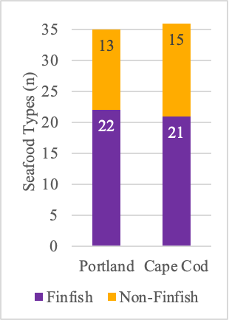
Figure 1: Number of types of finfish and non-finfish found on sampled menus for restaurants in Portland and Cape Cod. Seafood listed on menus were converted into seafood types using Table 1.

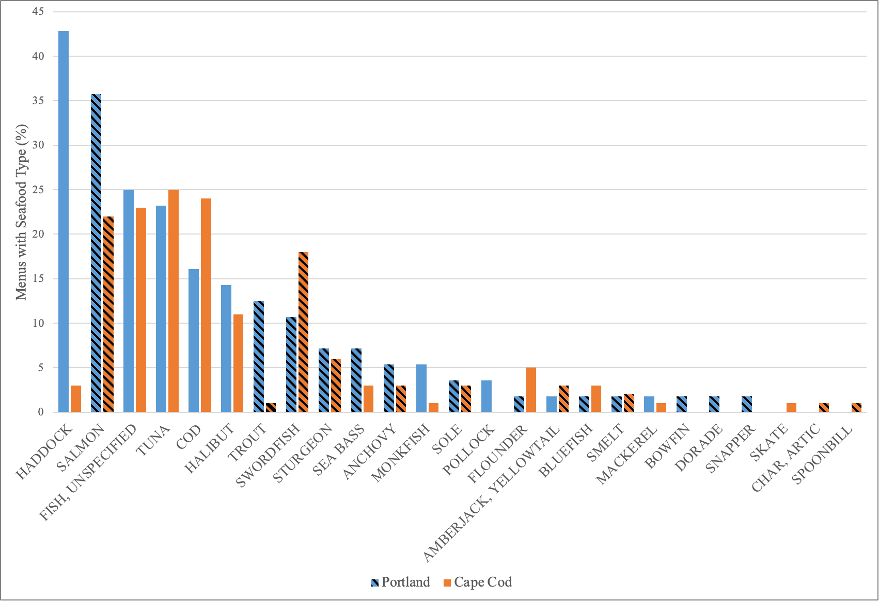
Figure 2: Percentage of restaurants sampled in Portland (blue bars) and Cape Cod (orange bars) with each finfish type on their menu. Seafood types are listed in descending order of the percentage of Portland restaurants with the seafood type on the menu. Striped bars indicate that the seafood type is not recorded in the non-confidential landings data for the region.

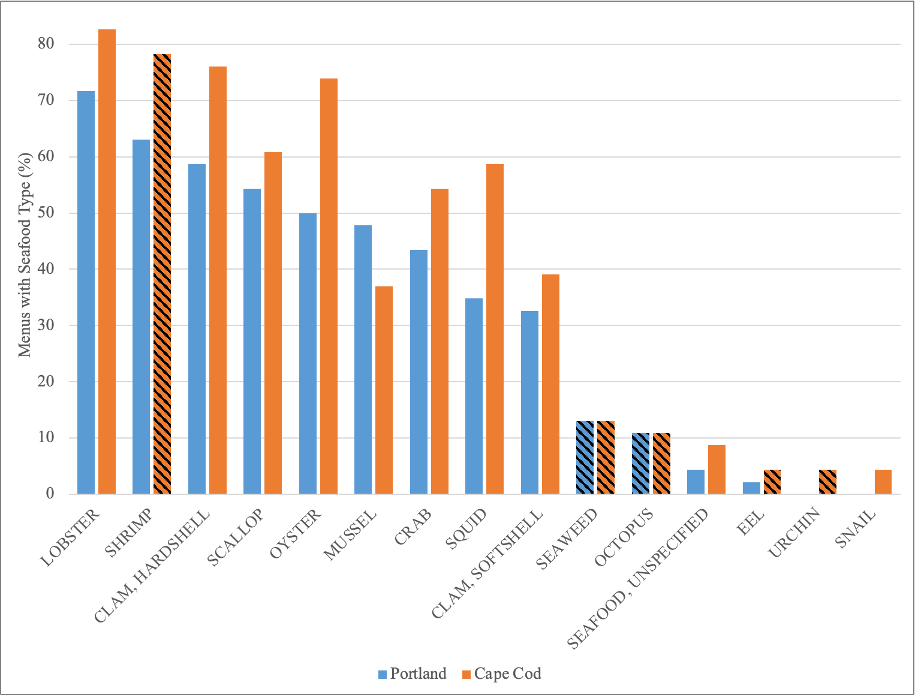

Figure 3: Percentage of restaurants sampled in Portland (blue bars) and Cape Cod (orange bars) with each non-finfish type on their menu. Seafood types are listed in descending order of the percentage of Portland restaurants with the seafood type on the menu. Striped bars indicate that the seafood type is not recorded in the non-confidential landings data for the region.

Menus vs. Landings Data

Within landings data, 31 species were landed in Portland, and 51 were landed in Cape Cod. These species were condensed into 27 seafood types (Table 2). Across both locations, a number of species were landed locally but did not appear on restaurant menus (Fig. 4; Table 2, Column 1). There were more seafood types that were in landings data but not on menus in Cape Cod than in Portland. This included some species that could be consumed but tend to be used for other products (e.g., herring, menhaden), elasmobranchs (e.g., dogfish, skates), and some whitefish that are similar to other broadly consumed species (e.g., hake, pollock).

In both locations, 21 seafood types were both on menus and in landings data (Fig. 4; Table 2, Column 2). Interestingly, the most common finfish on menus in each location (haddock in Portland and cod in Cape Cod) and the most common non-finfish (lobster for both locations) can be landed locally. Many other seafood types that were most commonly offered by restaurants—including clams, tuna, and crab—were also landed locally (Fig. 2-3). However, even if a seafood species can be landed locally, it is possible that restaurants might be purchasing that seafood type from other parts of the world.

In both locations, seafood that was not present in landings data also appeared on menus (Fig. 4; Table 2, Column 3). Menus in Portland included more species that were not present in landings data than restaurants than in Cape Cod. Salmon, which was especially prevalent on menus, is farmed in New England but not wild-caught. Shrimp, which was also very common on menus, presents an unusual case in that it is in landings data from the past five years, but cannot be commercially harvested, as a fishing moratorium was imposed in 2014. Shrimp only appeared in landings data in Portland because of a two-year allowance for fishermen to sell sampled shrimp from research trips despite the closed fishery. Meanwhile, other seafood, including seaweed, is landed locally but was reported confidentially because there were not enough suppliers to preserve anonymity.

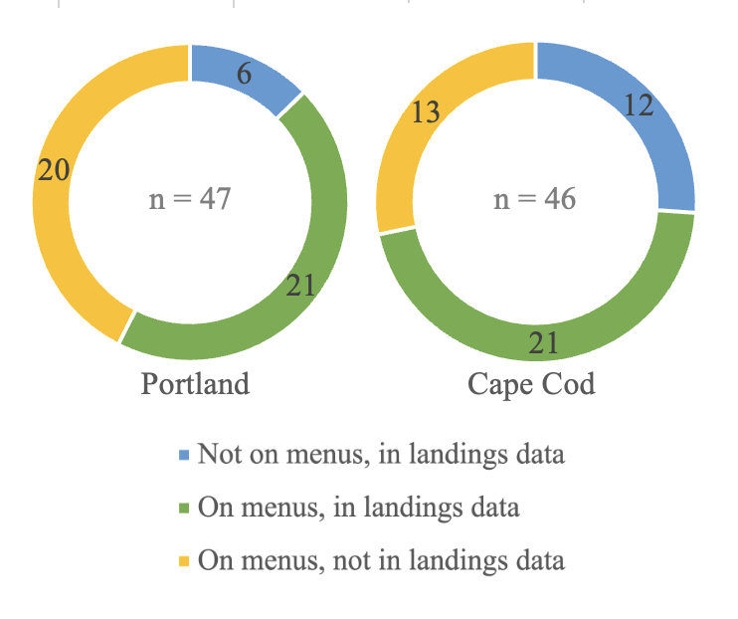
Figure 4: Counts of seafood types based on their representation on menus and in landings data in Portland and Cape Cod.

Table 2: Seafood types on menus and in landings data in Portland and Cape Cod. Seafood in landings data is listed in descending order based on the total landed volume in pounds between 2016 and 2021 for the respective location.
NOT ON MENUS IN PORTLAND,  IN PORTLAND LANDINGS DATA (6) | ON MENUS IN PORTLAND,  IN PORTLAND LANDINGS DATA (21) | ON MENUS IN PORTLAND,  NOT IN PORTLAND LANDINGS DATA (20)
HERRING (127,111,013 lb) | LOBSTER (19,981,023 lb) | AMBERJACK
MENHADEN (18,109,097 lb) | MACKEREL (4,796,717 lb) | ANCHOVY
HAKE (1,711,179 lb) | POLLOCK (3,303,162 lb) | BLUEFISH
HAGFISH (1,000,575 lb) | MONKFISH (1,947,156 lb) | BOWFIN
REDFISH (742,418 lb) | HADDOCK (1,733,887 lb) | DORADE
SKATE (2,865 lb) | FLOUNDER (1,577,266 lb) | OCTOPUS
 | TUNA (643,947) | SALMON
 | COD (​​401,255 lb) | SEA BASS
 | OYSTER (157,168 lb) | SEAWEED
 | SCALLOP (128,494 lb) | SMELT
 | CRAB (401,255 lb) | SNAPPER
 | CUSK (42,895 lb) | SOLE
 | SHRIMP (​​42,334 lb) | SPOONBILL
 | CLAM, HARD (36,349 lb) | STURGEON
 | MUSSEL (32,238 lb) | SWORDFISH
 | HALIBUT (20,688 lb) | TROUT
 | CLAM, SOFT (7,808 lb) | URCHIN
 | EEL (5,289 lb)
 | SQUID
 | FISH, UNSPECIFIED (NA)
 | SEAFOOD, UNSPECIFIED (NA)

NOT ON MENUS IN CAPE COD,  IN CAPE COD LANDINGS DATA (12) | ON MENUS IN CAPE COD,  IN CAPE COD LANDINGS DATA (21) | ON MENUS IN CAPE COD,  NOT IN CAPE COD LANDINGS DATA (13)
DOGFISH (43,887,857 lb) | SKATE (23,720,119 lb) | AMBERJACK
HAKE (522,756 lb) | LOBSTER (7,750,077 lb) | ANCHOVY
POLLOCK (206,372 lb) | MACKEREL (4,048,706 lb) | CHAR, ARTIC
MENHADEN (174,330 lb) | SCALLOP (3,220,602 lb) | EEL
SCUP (168,209 lb) | MONKFISH (2,972,777 lb) | OCTOPUS
BUTTERFISH (16,264 lb) | MUSSEL (2,513,756 lb) | SALMON
REDFISH (13,276 lb) | CLAM, HARD (1,555,277 lb) | SEAWEED
TAUTOG (11,537 lb) | CRAB (1,329,728 lb) | SHRIMP
CUSK (8,399 lb) | TUNA (972,800 lb) | SMELT
BONITO (2,876 lb) | SEA BASS (681,336 lb) | SOLE
TILEFISH (1,206 lb) | SNAIL (440,906 lb) | STURGEON
DORY (1,087 lb) | CLAM, SOFT (424,061 lb) | SWORDFISH
 | BLUEFISH (381,791 lb) | TROUT
 | FLOUNDER (372,095 lb)
 | COD (344,461 lb)
 | OYSTER (195,349 lb)
 | HADDOCK (170,493 lb)
 | SQUID (95,014 lb)
 | HALIBUT (11,055 lb)
 | FISH, UNSPECIFIED (NA)
 | SEAFOOD, UNSPECIFIED (NA)

Sourcing Specificity

Sourcing information was included on restaurant menus for 21 types of seafood (Fig. 5). The most specific sourcing information found on menus pertained to oysters. Raw-bar oysters were often listed with the exact location where they were harvested and/or the name of the specific oyster farm. Mussels were also listed on menus with a level of sourcing detail slightly less specific than the information for oysters. Lobster was also often described with some sourcing descriptor, although the wording was far less specific—usually just “local” or “fresh.”

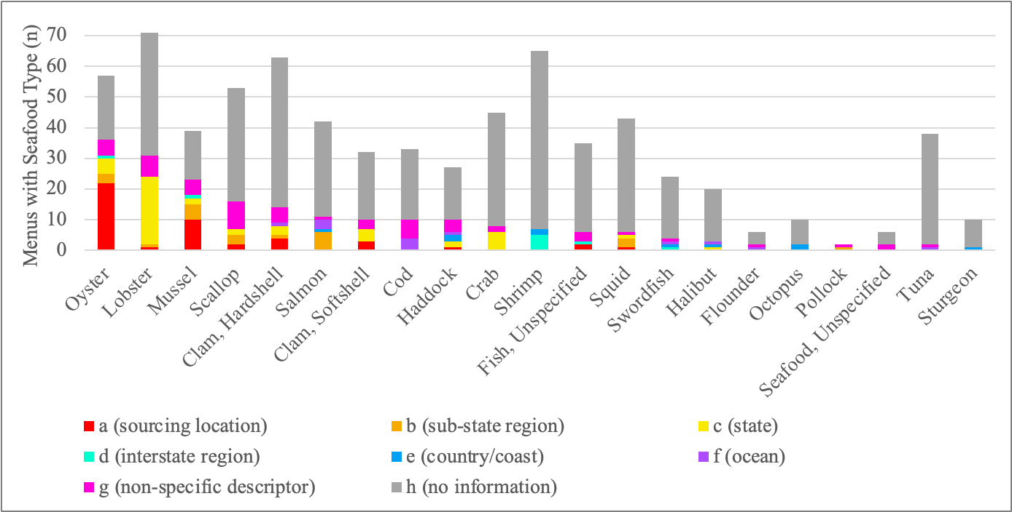
Figure 5: Number of menus that included sourcing information for different seafood types and the level of specificity presented for describing the source.

Of the 21 types of seafood with sourcing information on menus, 16 seafood types were specified to be local (Fig. 6). The five seafood types most commonly listed with sourcing information were the same five species that were most commonly described as local: oysters, lobster, mussels, scallops, and hardshell clams. Different types of seafood were described as local at different rates between Portland and Cape Cod. For instance, lobster was listed as local more commonly on Portland menus than on Cape Cod menus. Conversely, scallops and clams were listed as local more commonly on Cape Cod menus than Portland menus.
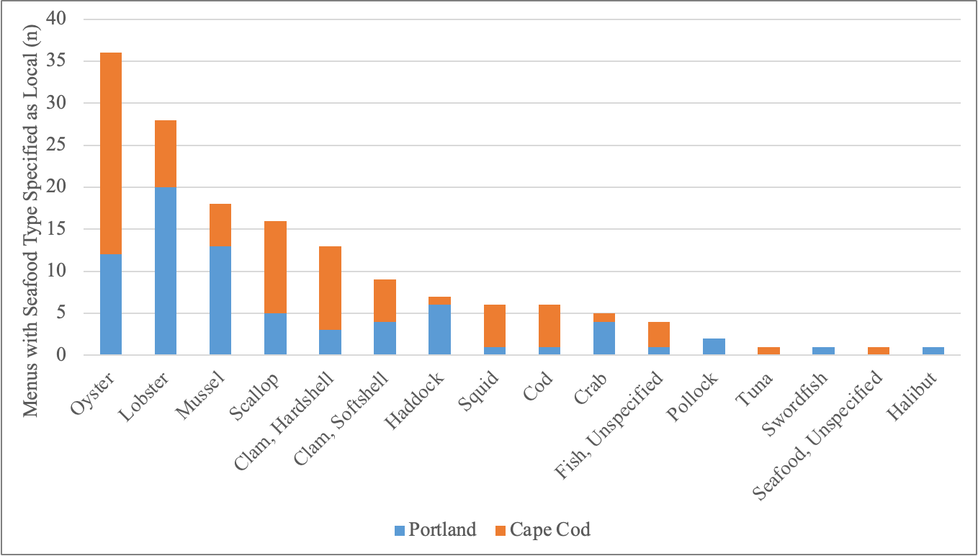

Figure 6: Number of menus that described seafood sources as Seafood with sourcing information on menus divided by ‘local’ for Portland (blue portion of bar) and Cape Cod (orange portion of bar). and ‘not local’ based on the information on the menu.

Website Messaging

Of the 102 restaurants in our sample, 65 restaurants (64% of the total sample) had some level of general or seafood specific messaging about ingredient sourcing on the non-menu portion of their website. Of the restaurants with sourcing messaging, 37 were in Portland and 28 were in Cape Cod. Messaging ranged in detail from a simple “fresh seafood” phrase to paragraphs about specific staff members’ commitment to building dishes around local and sustainable ingredients. Many restaurant websites also included generalized wording about their setting (52 restaurants), their relationship to the community (20 restaurants), and their customer base (25 restaurants). Sometimes messaging around these themes was related to seafood specifically, and sometimes it was not. Together, website messaging around the different topics was used to interpret the motivation for emphasizing local sourcing. Six values stood out as being connected to local sourcing for restaurants (Fig. 7)

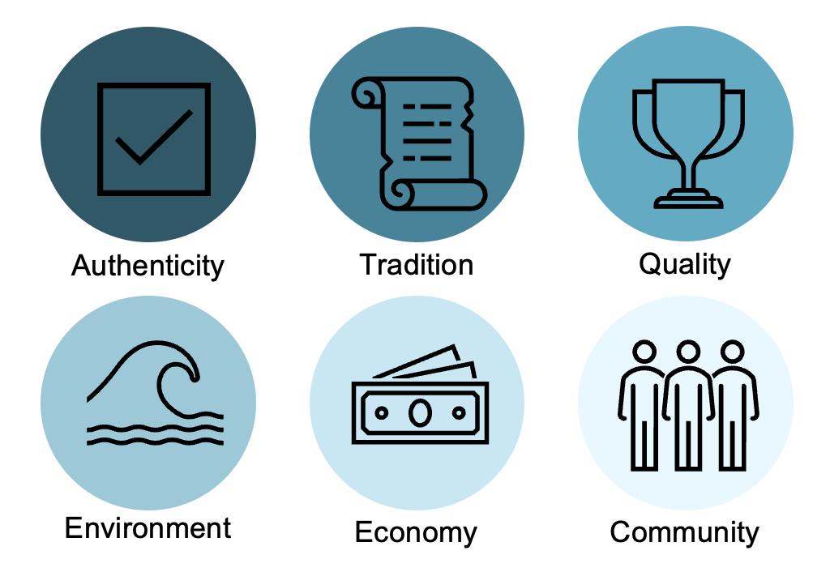

Figure 7: Values most commonly connected with local sourcing in the wording on restaurant websites. Values are listed in descending order of prevalence, with darker circles indicating more prevalent themes, and lighter circles indicating less prevalent themes.

Authenticity
Most restaurants included wording about fresh and local seafood on either their “Home” or “About” page. The word “local” was used in a non-menu context on 61 restaurant websites, and the word “fresh” was used on 42 restaurant websites. “Local” and “fresh” seem to be used interchangeably by restaurateurs. The principal role of these descriptors seems to be to assure the authenticity of the food served at the restaurant. Consumers are assumed to expect local seafood when eating out in coastal New England because, as one restaurant explained, “people seek out authentic local experiences.” Fresh, local seafood is integral to the “authentic” New England lifestyle restaurateurs are trying to sell.

Tradition
Tradition was the second most common value linked to local sourcing by restaurants on their websites. Restaurants in Cape Cod appear particularly eager to associate seafood with the “quintessential” place-based culture and tradition. One Provincetown restaurant harkened back to the “traditions of Old Cape Cod,” while another restaurant on the Cape promised “the food that defines summers on Cape Cod.” A third vowed to “honor the legacy of our setting with a menu that embraces the inn’s past and bridges the gap of time.” These nostalgic affirmations were often coupled with descriptions of spectacular waterfront views that will cement the diners’ connection to the coast.

Quality
Restaurants also described seafood as “local” and “fresh” to allude to the superior flavor of their food. One restaurant explained that “by partnering with local fishermen, we provide you the best, freshest seafood.” 17 restaurants spoke of “quality” when discussing ingredient sourcing. One Portland restaurant explained that their “chefs focus on serving the freshest seafood and the best ingredients available from local purveyors, fishermen and organic farmers. They prepare a simple yet creative menu that highlights the locally sourced ingredients.” This association of locality with flavor was especially common for Portland area restaurant websites.

Environment
The link between seafood sourcing and environmental sustainability was also emphasized slightly more in Portland than in Cape Cod. In all, 14 restaurants used some form of the word “sustainable” on their website, almost always in an environmental sense. While some restaurants simply added “sustainable” alongside “local” and “fresh,” others were more specific about their environmental background and approach. As gleaned by their websites, a chef at one Portland restaurant holds a BS in Wildlife Ecology, and another is a recipient of the Chefs’ Collaborative “Sustainer of the Year” award “for their work in sustainability and local food issues.” One Portland restaurant provides an overview of their partnership with GMRI, and another shared that they have moved beyond sourcing sustainability and have started “improving the other environmental impacts of our industry.” Two restaurants emphasized that they prioritize underutilized species to relieve pressure on overfished species.

Economy
Several restaurants in both Portland and Cape Cod list the specific suppliers they use for seafood and other ingredients, demonstrating their commitment to sourcing transparency. This level of transparency serves to solidify restaurants’ commitment to local stakeholders, bringing social and economic sustainability into restaurants’ impacts. As one Cape restaurant asserted, “not only does that [local seafood] make for a better-tasting and more unique meal, it helps our local economy, too." The word “fishermen” is used on fifteen restaurant websites, while the “working waterfront” is used on four restaurant websites, all in Portland. A Portland restaurant explained that they were “created to best serve the working waterfront” and that they “continue to honor those who have dedicated their years to Maine fisheries and aquaculture.” Other restaurants mentioned their proximity to the working waterfront less as a testament to their role in the local economy, and more as a marker of their authenticity.

Community
“Community” was used on 19 restaurant websites. A few restaurants identified their stakeholders and responsibility to the community more broadly. One Portland restaurant explained that they “consistently engage with and advocate for our stakeholders across Maine’s coasts, from 6th generation fishing families to first generation immigrants who are the backbone of Maine’s seafood production industry." Several restaurants also highlighted their fundraising and volunteering in the local community.

Key-Informant Interviews

Interviewees

Five interviews were conducted with experts on the seafood industry in New England to gain insights on opportunities, incentives, and challenges for sourcing more diverse, local seafood. Because the interviewees were selected based on suggestions from the Sustainable Seafood Team at GMRI, they tended to work for businesses with a strong focus on local foods and serving the community. In this regard, they were not fully representative of the types of perspectives that would be found in a random sample. The five experts represented restaurants, wholesale, and direct-to-consumer businesses—all based in Maine, and mostly catering to higher-end clients. They spend their time fulfilling a wide variety of responsibilities, from managerial tasks like accounting, purchasing, and menu planning, to hands-on tasks like food preparation, and even public speaking and advocacy.

Perspectives on Diverse, Local Seafood

“Our mission is to support the working waterfront here in Maine. We feel that by purchasing products from local Maine harvesters, we are doing our part in terms of actually sustaining the environment, as our Maine fishing people are excellent stewards of the environment and also protectors of the working waterfront.”

“I like to make do with the whole range of Gulf of Maine species that are available. And I love that they change day to day, week to week, season to season, I think that’s terrific.”

Interviewees touched on multiple reasons for offering diverse, local seafood options, including superior flavor, environmental responsibility, and support for the local economy. Chefs each listed a wide range of seafood species which they enjoy using, including both finfish and non-finfish. Though all interviewees prefer working with local seafood, some were more willing to use imported products in certain cases. Interviewees were unanimously supportive of aquacultured shellfish, but had varying opinions on aquacultured finfish. One chef expressed their enthusiasm about innovations in fish feed and explained that “we can’t separate the conversation about aquaculture and wild because seafood is a singular category as understood by the public.” Conversely, another chef shared that they shy away from farmed products for entrée portions of fish. Most interviewees were excited about using underutilized species, because they can help a restaurant deliver a dining experience that consumers’ “jaded palates have not yet experienced.” One interviewee disagreed on the potential of using underutilized species, explaining that “the reason people don’t want to use them is that they’re just not as user-friendly.” He suggested rose fish as an example of a bony fish that is difficult to filet and has low yields—qualities that would make it unattractive for restaurants, who must process many fish every day. In addition, multiple interviewees stressed the importance of seasonality, and explained that they are able to adapt to shifting local availability by frequently re-printing menus.

Supply Chain Challenges

“The supply tends to be much more centralized and tends to favor big boats over small boats. I don’t know why. I wish I knew all of the policies that made that be the case. But things are in constant change, that’s the only constant.”

“Our seafood industry isn’t well set up for handling fish nicely.”

Interviewees underscored that the decisions they make about which species they use and how they source them are heavily influenced by external factors in the broader supply chain. Interviewees shared concerns about poor handling of seafood throughout the supply chain, emphasizing that gentler handling by fishermen and distributors would result in a better-quality product. Interviewees had varying perspectives on the effects of supply chain centralization. One interviewee suggested that a central distribution network between northern and southern coastal Maine could help increase the accessibility of local seafood. Conversely, another interviewee described their challenges sourcing local crab and species from winter fisheries because of increased centralization. In some cases, back-of-house labor shortages are also a barrier to using underutilized species, as some types of fish are “hard to be able to process in a way that is then easy to use on the menu.” When asked about the potential for larger restaurant chains to diversify their seafood offerings, interviewees expressed varying opinions. One chef was optimistic that mainstream food chains could eventually work to introduce consumers to new species, while another doubted that a chain would “mess around with anything that has a variable in it.” In their own businesses, some interviewees identified lower supply and higher price-point as a factor limiting their adoption of emerging species, while others explained that lower demand can make underutilized seafood less expensive.

Ecological Awareness

“It’s not that climate change is going to happen, it’s already happening.”

“We do our best to purchase sustainably, to purchase from harvesters that we know care about the environment and at this point that’s the best we can do with regards to climate change.”

Interviewees demonstrated that stakeholders in the seafood industry are in tune with changing ecological conditions, both in the short and long term. Industry members recognize that climate change is already affecting local species availability. Multiple interviewees brought up the collapse of the Maine shrimp fishery, citing warming waters and overfishing as probable causes. In the near-term future, chefs are particularly concerned about the lobster fishery, as “lobsters moving north to Canada is a pretty frightening thought” for the Maine image. One interviewee also expressed their concern “about the acidification of waters and long-term viability of our shellfish.” While stakeholders in the seafood industry are certainly wary of the effects of climate change, they are also curious about the opportunities brought by newly local species. As one interviewee explained, “we don’t want climate change, we don’t want the waters to be warming, but a side benefit of that is things like black bass or fluke coming into our waters, which would be pretty cool.”

Consumer Demand

“There needs to be a public perception switch about what’s good fish and what’s good and approachable.”

“I think it’s about training the consumer more than the restaurant.”

Interviewees all recognized that the restaurant industry is in a unique position to introduce consumers to diverse, high-quality local seafood. One restaurateur explained that restaurants have a responsibility to be “pushing out fish that are slightly different and having a good explanation for it.” Well-established, higher-end restaurants often have the social capital to sell dishes made with underutilized species without much resistance, especially when the back and front of the house work together to make new species approachable and appealing. For most restaurants, however, consumer unfamiliarity can make offering a new species a risk. As one interviewee explained, many consumers have “known what they like and they just stick with it.” If consumers are unwilling to try new seafood species, restaurants have no reason to buy underutilized species and include them on their menu. Often, a certain level of consumer demand must be met for a restaurant to offer new seafood. As one interviewee explained, “the more demand, the more restaurants are going to make that extra effort to do something different.” Many restaurateurs are willing to do their part to push new species, but they need support from other organizations to make their efforts pay off. One interviewee shared his appreciation for campaigns that “get people aware that there are more than just the four fish out there that exist that people can eat and enjoy.” Some interviewees suggested that this momentum could come from non-profit organizations, while others did not specify how they envision consumer demand broadening.

Opportunity Areas

Based on conversations with chefs and analysis of current menus, there were five seafood strategies that stood out as opportunity areas for restaurants to increase the long-term sustainability of the local seafood industry by diversifying seafood offerings and supporting New England fisheries (Table 3). Each strategy is principally concerned with a specific group of species.

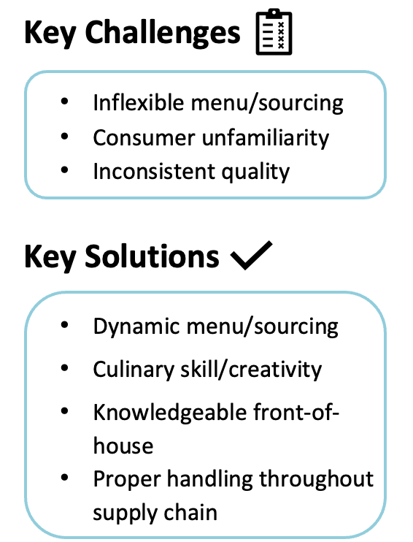
Strategy | Species | Summary
Everywhere (On Menus) But Here (in the Ocean*)  *For the most part | Salmon & Shrimp | Assess the most sustainable sourcing within popular seafood categories and consider adding other, local species to the menu.
Your Seafood Wuz Here | Oysters & Mussels | Draw from hyper-local branding strategies used for oysters and mussels to build demand for other local seafood.
A Fish By Any Other Name | Whitefish (Cod, Haddock, Hake, Pollock), Tuna, Crab | Substitute non-local species in unspecific dishes on menus (i.e. crab cake, fish taco, tuna crudo) with seasonal, local species.
Fish Are Moving North; Let’s Keep Up With The Catch | Black Sea Bass, Squid, Bluefish | Introduce customers to emerging species by offering creative preparations explained by knowledgeable waitstaff.
Little Guys Are Food Too | Mackerel, Herring, Whelks | Incorporate species from lower trophic levels onto the menu to encourage customers to broaden which species they think of as food.

Figure 7: Key strategies for incorporating more diverse and/or local seafood onto menus.

Everywhere (On Menus) But Here (in the Ocean)

Salmon and shrimp make up 45% of national seafood consumption (Chase 2023), likely because of their mild taste, versatile applications, wide availability, and relatively low cost. Even in Portland and Cape Cod, where this seafood is not locally wild-caught, salmon and shrimp are omnipresent on menus. One chef explained that restaurants feel compelled to include salmon and shrimp on their menus, even in Maine, because “a lot of tourists [...] don’t really understand that those things may not be representative of Maine seafood.” Because of this consistent high demand, replacing wild shrimp or salmon with a different, local wild-caught option might not be realistic, and adding an additional type of seafood to the menu might be overly costly for some restaurants. Another interviewee emphasized that the question is not about replacing shrimp and salmon on menus, but rather “how do we best make our decisions within these categories that chefs are, to a great extent, forced to participate in?” Although restaurants do not support local commercial fisheries by serving salmon and shrimp, they can still support sustainable food systems while keeping these familiar favorites on the menu. To maximize the environmental and economic benefits of their purchasing decisions, chefs can select the salmon and shrimp that are produced closer by and/or using best practices within their category. Salmon, for instance, is already farmed in the Gulf of Maine, and will likely soon be farmed on Maine land as well. If there is an opportunity to buy seafood that is farmed nearby, the purchase will still support the local economy and result in lower transportation emissions.

Your Seafood Wuz Here

In contrast to shrimp and salmon, which are rarely described with any sourcing details on menus, oysters and mussels are often accompanied by a wealth of sourcing information. Local sourcing information about oysters and mussels is abundant because traceability is built into the bivalve shellfish regulatory system for public health reasons. Farmers emphasize and leverage the sourcing information to build demand for their products, as consumers associate geographic specificity with flavor and quality, just like they do for wine. In part, this is likely because of how bivalves develop flavor and how the aquaculture process allows for more easily traceable supply chains. However, there is the opportunity to draw from the strategies already used to sell oysters and mussels for other seafood as well. As one interviewee explained, “Maine sells a story, and we need to shift other species into that story.” In some cases, the menu itself might be an appropriate medium through which to tell the story of the seafood on a consumer’s plate. However, restaurateurs are wary of overloading printed menus with additional words, as “there’s only so much people will read.” In many cases, the origin story of a seafood product is best told by well-informed waitstaff, who can explain where a species came from. As one chef explained, “the front-of-house is our line of communication to the consumer,” and information about where specific seafood items are from is shared with staff as menu options change. Another venue for seafood story-telling is a business’s website or social media. Regardless of where a restaurant decides to tell the sourcing story, it can reap the benefits of positive geographic associations. As one business owner stated, “people will choose Maine products over others all day long.”

A Fish By Any Other Name

Whitefish, tuna, and crab, as general categories, are both landed in New England and frequently appear on menus. However, the species that is offered at restaurants is not always the species that is caught locally. For instance, a fish sandwich, crabcake, or tuna crudo, could be made with tilapia, king crab, or ahi tuna, which are not landed in New England. Conversely, they could also be made with pollock, Jonah crab, or bluefin tuna, which can be landed locally. If a menu does not specify the species or its source, a consumer has no way of knowing what the seafood is and whether it was landed locally without asking front-of-house staff, who may or may not know the answer. While this lack of clarity might be frustrating for a dedicated local eater looking for transparency, it also presents an opportunity to substitute in local, seasonal species into the existing menu. As availability of local species shifts because of fishing effort, seasons, or climate, chefs can switch the species they use to prepare the same dishes they know consumers want. As one chef put it, restaurants “sell the dish, not the fish.” Another chef explained that underutilized species “may have different names, but they’re incredibly delicious and they’re very approachable fish, especially when you get into things like pollock and hake, which are much more akin to cod and haddock, which people are very familiar with.” By purchasing seafood that is locally available, restaurants support environmental, economic, and social sustainability in their community.
Restaurants that are presently relying on a consistent supply of imported species might have to invest some time and money to switch to a more dynamic, local sourcing approach. As one interviewee explained, there are “shifts that need to happen not necessarily from a culinary perspective, but from an operations and standards perspective.” Although it may be advantageous for a restaurant to use general wording for seafood dishes (i.e. “catch-of-the-day”) on their menu, species-level information should be readily available for interested consumers to maintain transparency and build trust and credibility. Species that are currently in-use could be shared by waitstaff or listed on a regularly-updated chalkboard, which would also demonstrate the restaurant’s commitment to freshness. By gently introducing consumers to seasonal, local species, restaurants also support a shift towards sustainable seafood systems on the demand side. As one chef explained, there is “great virtue and value to be gained broadly by exposing people to the fact that they already like these things they think they’re unfamiliar with.”

Fish Are Moving North; Let’s Keep Up With The Catch

Just as some species are becoming less abundant locally because of warming waters, other species, like black sea bass, longfin squid, and bluefish are moving into the Gulf of Maine. By including these species on the menu, restaurateurs can help support local fishermen as they adapt to climate change. The challenge with some emerging species is that they are less familiar to consumers. Both the front and back of house can help ensure that consumers have a positive experience trying a new species. One industry expert explained that he “mitigated” consumer hesitancy to try new species by “having a really well-trained dining room staff” who “were really well informed and tasted all of the maybe unusual species that ended up on the menu and could give people a good idea of what they could expect from it.” Another chef explained that “we try to get creative in the kitchen and try to serve them [underutilized species] in ways that are exciting for guests to try.” Some species may require extra skill to prepare, so trained labor may be an additional constraint. Putting emerging species on a menu requires intentionality and flexibility both in the sourcing process and menu creation. One interviewee who takes pride in featuring underutilized, emerging species re-prints menus multiple times a day to allow for the fluctuating availability of species and the corresponding seafood offerings. Another industry member who has successfully created a dynamic business model explained that “we're able to adjust from day to day, based on what’s available and the trends in the market. We shrug and say what comes, comes.”

Little Guys Are Food Too

Species like mackerel, herring, and whelks are abundant in the areas around Portland and Cape Cod, but are rarely eaten in New England. Just as with terrestrial foods, seafoods from lower trophic levels generally have lower carbon footprints because energy is not wasted as the lower trophic level becomes an input for organisms in higher trophic levels (Bianchi et al. 2022). As a double benefit, small pelagic fish and mollusks also provide key nutrients. While including physically smaller species on restaurant menus holds great potential, this shift also involves significant challenges. New England consumers do not think of smaller species as food sources because they are generally used as bait. The mindset around species like mackerel and herring is “fish as commodity rather than fish as luxury and engagement with an ecosystem.” For this reason, smaller fish are “often handled very roughly, in less than ideal conditions for restaurants.” Interviewees were quick to point out that “the lower the level on the food chain, the lower care that goes into that fish.” The barrier to including smaller species on menus is largely a supply chain issue. Training and infrastructure are key to ensure that fish are treated more gently from the moment they are pulled out of the water. While this supply chain solution requires investment, it also has the potential to enrich local fishing economies by increasing the value of traditional bait species. One restaurateur emphasized that “everyone makes a little bit more money off of it if there’s more intention and care from the get-go.” Once species from lower trophic levels make it into the kitchen, chefs must rely on technical skill and culinary creativity to transform them into dishes that are enticing and approachable for consumers. In some cases, smaller species may require more labor to prepare, so they may be more viable to offer in the off-season, when chefs have more time.

Discussion

Overall, considerable seafood diversity was represented on menus examined for this study, with thirty-five types of seafood represented on at least one menu in Portland or Cape Cod. This is likely because restaurants in Portland and Cape Cod are able to source less common species and have the technical skill and confidence to handle them. While only three species still represent over half of the seafood eaten in the United States, there are signs that this trend may be changing (Chase, 2023). In 2021, the top 10 seafood species consumed made up 76% of all seafood consumed in the U.S., which is down from nearly 90% in years prior, and suggests that more types of species are making their way onto consumers’ plates (Chase, 2023). New England restaurants can continue building momentum around local, diverse seafood consumption by creating more opportunities for consumers to try different species and by educating consumers about the source of their seafood.

While it is promising that so many types of seafood are represented on at least one menu, consideration is also needed regarding the frequency and volume for each type of seafood on menus or in individual dishes. For example, a menu might have one dish with an underutilized species used as a component, and seven dishes with a more mainstream species used as the main ingredient, thus causing seafood diversity to be lower than portrayed. As such, the data collected in this study likely overstates seafood diversity because it did not account for how many times each type of seafood appeared on each menu or in what volume each type of seafood was used in each dish. Such analyses were beyond the scope of this study, but others have examined this issue. For example, in addition to calculating the percentage of Boston restaurants with each type of seafood, Davis tracked how many times each type of seafood appeared on each menu (Davis, 2020). This work suggests that species like shrimp, salmon, and tuna not only appear on more menus, but also appear more times on each menu (Davis 2020). In addition to collecting these types of information from menus, a future study could also examine restaurant purchasing records to compare the volume of species used in restaurants to the volume of species landed locally. A future study could also break species down by trophic level to examine where on the food chain consumers are eating at restaurants.

Results also indicate that the types of seafood most commonly offered at restaurants can be landed locally. However, this does not mean that locally landed seafood makes up half of seafood at Portland and Cape Cod restaurants. The percentage of local seafood served at restaurants is likely much lower because there are many non-local seafood options that may be more attractive or readily available to restaurants. The exact quantity of local sourcing is unknowable based solely on analysis of restaurant menus, as they generally include little or no sourcing information. For instance, bluefin tuna is landed in both Portland and Cape Cod, but a restaurant could be using ahi tuna, which is not a species landed locally, in their dish labeled simply as “Tuna.” Even if a restaurant is using bluefin tuna, they could be importing it from overseas. More in-depth research would have to be conducted to assess the actual breakdown of local seafood at New England restaurants. A future study could also examine how much information servers and other consumer-facing personnel in the seafood industry have about the sourcing of the seafood they are serving.

Incorporating local species onto menus is especially important as species shift northwards due to warming ocean temperatures. Few Cape Cod restaurants currently offer emerging species such as black sea bass, dogfish, and monkfish. Restaurants with dynamic menus are best positioned to more readily adapt to changes in species availability and offer ‘new’ or emerging species as they come into local waters, thus supporting the local fishing industry as they adapt their catch. A study incorporating longer-term ecological data and a broader geographic range could illuminate more significant correlations between shifting species and restaurant offerings. While restaurants do play a key role in popularizing new species and increasing the resilience of the local seafood industry, other factors along the supply chain also need to be considered, including consistency in availability and fishery management systems, which impact how fishers are able to diversify to new species.

Many restaurants emphasized local sourcing on their website, but specific sourcing information on most menus was limited or non-existent. Different restaurants emphasized local sourcing for different reasons, but most businesses' values and priorities align well with increasing community-specific environmental and economic sustainability. Further efforts need to be taken to put these values into action. Importantly, for the restaurant industry, sourcing diverse, local seafood is not a “why” problem as much as it is a “how” and “when” problem. Organizations that promote local seafood can use the data and opportunity areas highlighted in this study to catalyze change throughout the seafood supply chain and initiate public awareness campaigns about diverse, local seafood. Future studies that examine seafood sustainability from a supply-chain perspective would continue to help inform action by stakeholder groups, particularly the restaurant industry, which has traditionally been left out of rigorous, solution-oriented research about sustainable food systems.

Conclusion

When travelers drive across the state border into Maine, they are confronted with a sign that reminds them that Maine is “The Way Life Should Be.” For many, especially tourists, this means some delicious seafood with a view of the water. The seafood could be a lobster roll or some nice cod, but Maine is “The Way Life Should Be,” not “The Way Life Has Been.” Restaurants can play a key role in shaping the future of New England’s seafood industry because of their influence on consumers and leverage in supply chains. Already, Portland and Cape Cod restaurants offer far more diverse seafood options than are generally represented in the average American diet, and the types of seafood most commonly offered can be landed locally. Forward-thinking restaurateurs are excited about introducing the public to less common species, but they recognize that successfully putting these species on the menu may require coordinated operational shifts in multiple areas of the business. We identified five strategies associated with different sets of species that can help restaurants diversify their seafood offerings to align with locally-available species. This alignment will be particularly important for supporting the long-term sustainability of fisheries and economic vitality of coastal communities as climate change alters current fisheries and the species they harvest. In this manner, restaurants can play important lead roles in collective efforts that operate across the supply chain, influence local consumer choices, and enable iconic working waterfronts to stay open for business.

References

Alden, R. (2011). Building a Sustainable Seafood System for Maine. Maine Policy Review, 20(1), 87–95. https://doi.org/10.53558/RPTN2038
Bianchi, M., Hallström, E., Parker, R. W. R., Mifflin, K., Tyedmers, P., & Ziegler, F. (2022). Assessing seafood nutritional diversity together with climate impacts informs more comprehensive dietary advice. Communications Earth & Environment, 3(1), 1–12. https://doi.org/10.1038/s43247-022-00516-4
Chase, C. (2023, June 7). Americans consumed a record amount of seafood in 2021. Seafood Source. https://www.seafoodsource.com/news/foodservice-retail/americans-consumed-a-record-amount-of-seafood-in-2021
Davis, A. (2020). New England’s Underutilized Seafood Species: Defining And Exploring Marketplace Potential In A Changing Climate. https://doi.org/10.7275/18889629
Davis, A. G., Staudinger, M. D., & Mills, K. E. (2023). Identifying New England’s underutilized seafood species and evaluating their market potential in a changing climate. Frontiers in Marine Science, 10, 1226219. https://doi.org/10.3389/fmars.2023.1226219
Gephart, J. A., Davis, K. F., Emery, K. A., Leach, A. M., Galloway, J. N., & Pace, M. L. (2016). The environmental cost of subsistence: Optimizing diets to minimize footprints. Science of The Total Environment, 553, 120–127. https://doi.org/10.1016/j.scitotenv.2016.02.050
Gephart, J. A., Henriksson, P. J. G., Parker, R. W. R., Shepon, A., Gorospe, K. D., Bergman, K., Eshel, G., Golden, C. D., Halpern, B. S., Hornborg, S., Jonell, M., Metian, M., Mifflin, K., Newton, R., Tyedmers, P., Zhang, W., Ziegler, F., & Troell, M. (2021). Environmental performance of blue foods. Nature, 597(7876), 360–365. https://doi.org/10.1038/s41586-021-03889-2
Gutiérrez, A. T., & Morgan, S. K. (2015). The influence of the Sustainable Seafood Movement in the US and UK capture fisheries supply chain and fisheries governance. Frontiers in Marine Science, 2. https://doi.org/10.3389/fmars.2015.00072
Hallström, E., Bergman, K., Mifflin, K., Parker, R., Tyedmers, P., Troell, M., & Ziegler, F. (2019). Combined climate and nutritional performance of seafoods. Journal of Cleaner Production, 230, 402–411. https://doi.org/10.1016/j.jclepro.2019.04.229
Jacquet, J. L., & Pauly, D. (2008). Trade secrets: Renaming and mislabeling of seafood. Marine Policy, 32(3), 309–318. https://doi.org/10.1016/j.marpol.2007.06.007
Jacquet, J., & Pauly, D. (2008). Funding Priorities: Big Barriers to Small-Scale Fisheries: Funding for Fisheries. Conservation Biology, 22(4), 832–835. https://doi.org/10.1111/j.1523-1739.2008.00978.x
Kurlanksy, M. (1998). Cod: A Biography of the Fish that Changed the World. Penguin Books.
Le Bris, A., Mills, K. E., Wahle, R. A., Chen, Y., Alexander, M. A., Allyn, A. J., Schuetz, J. G., Scott, J. D., & Pershing, A. J. (2018). Climate vulnerability and resilience in the most valuable North American fishery. Proceedings of the National Academy of Sciences, 115(8), 1831–1836. https://doi.org/10.1073/pnas.1711122115
Love, D. C., Asche, F., Conrad, Z., Young, R., Harding, J., Nussbaumer, E. M., Thorne-Lyman, A. L., & Neff, R. (2020). Food Sources and Expenditures for Seafood in the United States. Nutrients, 12(6), 1810. https://doi.org/10.3390/nu12061810
Love, D. C., Asche, F., Young, R., Nussbaumer, E. M., Anderson, J. L., Botta, R., Conrad, Z., Froehlich, H. E., Garlock, T. M., Gephart, J. A., Ropicki, A., Stoll, J. S., & Thorne-Lyman, A. L. (2022). An Overview of Retail Sales of Seafood in the USA, 2017–2019. Reviews in Fisheries Science & Aquaculture, 30(2), 259–270. https://doi.org/10.1080/23308249.2021.1946481
Masury, K., & Schumann, S. (2019). Eat like a fish: Diversifying New England’s seafood marketplace.
National Marine Fisheries Service. (2021). Fisheries Economics of the United States 2018 (NOAA Tech. Memo NMFS-F/SPO-225; p. 246). U.S. Deptartement of Commerce.
National Marine Fisheries Service. (2022). Fisheries of the United States, 2020 (NOAA Current Fishery Statistics No. 2020). U.S. Department of Commerce.
Northeast Fisheries Science Center. (2022, August 26). A Brief History of the Groundfishing Industry of New England. NOAA Fisheries. https://www.fisheries.noaa.gov/new-england-mid-atlantic/commercial-fishing/brief-history-groundfishing-industry-new-england
Olson, J., Clay, P. M., & Pinto da Silva, P. (2014). Putting the seafood in sustainable food systems. Marine Policy, 43, 104–111. https://doi.org/10.1016/j.marpol.2013.05.001
Oremus, K. L., Frank, E. G., Adelman, J. J., Cruz, S., Herndon, J., Sewell, B., & Suatoni, L. (2023). Underfished or unwanted? Science, 380(6645), 585–588. https://doi.org/10.1126/science.adf5595
Pinsky, M. L., Selden, R. L., & Kitchel, Z. J. (2020). Climate-Driven Shifts in Marine Species Ranges: Scaling from Organisms to Communities. Annual Review of Marine Science, 12(1), 153–179. https://doi.org/10.1146/annurev-marine-010419-010916
SEAMaine. (2023). SEA Maine Releases First Economic Report on the Entire Maine Seafood Sector (p. 3).
Seaver, B. (2017). American Seafood: Heritage, Culture & Cookery From Sea to Shining Sea - A Cookbook. Union Square & Co.
Stoll, J. S., Harrison, H. L., De Sousa, E., Callaway, D., Collier, M., Harrell, K., Jones, B., Kastlunger, J., Kramer, E., Kurian, S., Lovewell, M. A., Strobel, S., Sylvester, T., Tolley, B., Tomlinson, A., White, E. R., Young, T., & Loring, P. A. (2021). Alternative Seafood Networks During COVID-19: Implications for Resilience and Sustainability. Frontiers in Sustainable Food Systems, 5. https://www.frontiersin.org/articles/10.3389/fsufs.2021.614368
Witkin, T., Dissanayake, S., & McClenachan. (2015). Opportunities and barriers for fisheries diversification: Consumer choice in New England. Fisheries Research, 168, 56–62. https://doi.org/10.1016/j.fishres.2015.03.019

